**Assignment 1009**

1. **”Hello”**

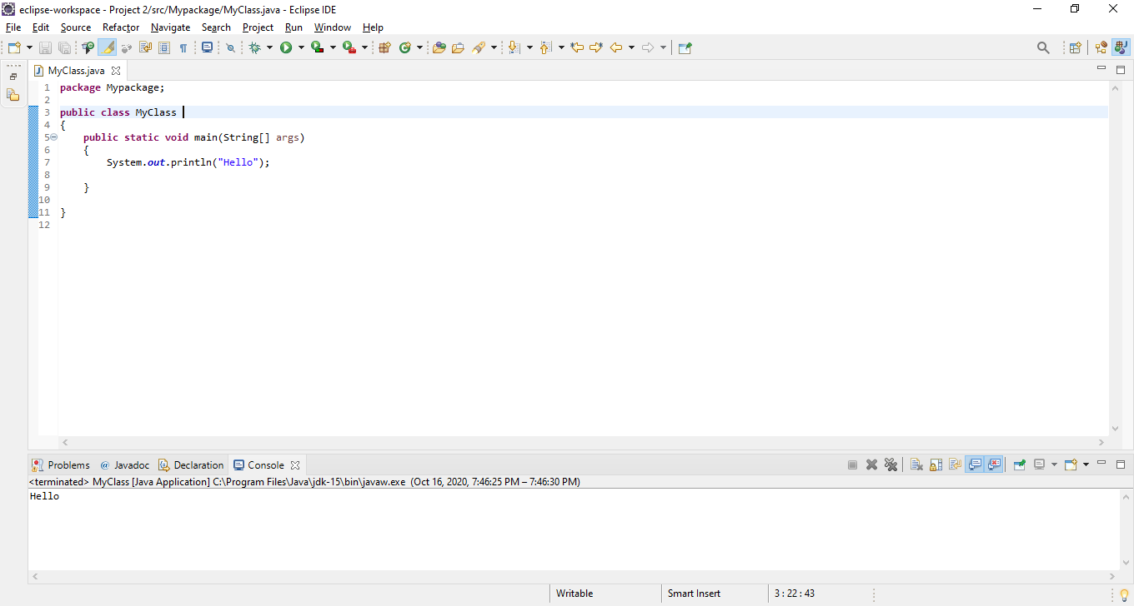

**II. Integers**

package Mypackage;

public class MyClass

{

public static void main(String[] args)

{

int a=99;

int b=11111;

System.out.println (a*b);

}

}

Answer: 1099989

package Mypackage;

public class MyClass

{

public static void main(String[] args)

{

int a=10;

int b=11112;

System.out.println (a*b);

}

}

Answer: 111120

**III. Difference between Int & Float:**

The difference between Integer and Float is that integer is a variable that allows you to only use whole numbers in a program. Float allows you to use decimals.

**IV. Read Name:**

package Mypackage;

import java.util.Scanner;

public class MyClass

{

public static void main(String[] args)

{

String name;

Scanner obj = new Scanner(System.in);

System.out.println("Enter your name");

name=obj.next();

System.out.println("Your entered: "+name);

}

}

Enter your name

Lorpu

Your entered: Lorpu